MODULE 4

**RISK MANAGEMENT**

Topics:

* Risk identification
* Assessment
* Risk Planning
* Risk Management
* PERT technique
* Monte Carlo simulation
* Resource Allocation
* Creation of critical paths
* Cost schedules



What is Risk?

There is no formal definition but the general agreement is that risk always involves two characteristics:

*uncertainty*—the risk may or may not happen; that is, there are no 100 percent probable risks

—and *loss*—if the risk becomes a reality, unwanted consequences or losses will occur. When risks are analyzed, it is important to quantify the level of uncertainty and the degree of loss associated with each risk.

*Project risks* threaten the project plan. That is, if project risks become real, it is likely that the project schedule will slip and that costs will increase. Project risks identify potential budgetary, schedule, personnel (staffing and organization), resource, stakeholder, and requirements problems and their impact on a software project.

**Types of Risks**

*Technical risks* threaten the quality and timeliness of the software to be produced. If a technical risk becomes a reality, implementation may become difficult or impossible. Technical risks identify potential design, implementation, interface, verification, and maintenance problems. In addition, specification ambiguity, technical uncertainty, technical obsolescence, and “leading-edge” technology are also risk factors. Technical risks occur because the problem is harder to solve.

*Business risks* threaten the viability of the software to be built and often jeopardize the project or the product. Candidates for the top five business risks are (1) building an excellent product or system that no one really wants (market risk), (2) building a product that no longer fits into the overall business strategy for the company (strategic risk), (3) building a product that the sales force doesn’t understand how to sell (sales risk), (4) losing the support of senior management due to a change in focus or a change in people (management risk), and (5) losing budgetary or personnel commitment (budget risks).

*Unpredictable risks* -They can and do occur, but they are extremely difficult to identify in

advance.

The different types of risks your software project can encounter are:

**Technical Risks**

These can arise due to the software and hardware technologies and tools being used in software development.

**Human Resource Risks**

These can arise due to an error on the part of the software development team.

**Requirement Risks**

A change in the customer/client’s requirements and the process of fulfilling these requirements may pose a risk to the software product.

**Estimation Risks**

Poor estimations in terms of cost and time may affect a risk-free delivery of software products.

# RISK IDENTIFICATION

For identifying risk, project team should review scope of program, estimate cost, schedule, technical maturity, parameters of key performance, etc. To manage risk, project team or organization are needed to know about what risks it faces, and then to evaluate them. Generally, identification of risk is an iterative process. It basically includes generating or creating comprehensive list of threats and opportunities that are based on events that can enhance, prevent, degrade, accelerate, or might delay successful achievement of objectives.

By identifying known and predictable risks, the project manager takes a first step toward avoiding them when possible and controlling them when necessary.

***Generic risks***are a potential threat to every software project.

***Product-specific risks***can be identified only by those with a clear understanding of the technology, the people, and the environment that is specific to the software that is to be built. To identify product-specific risks, the project plan and the software statement of scope are examined.

One method for identifying risks is to create a **risk item checklist**. The checklist can be used for risk identification and focuses on some subset of known and predictable risks in the following generic subcategories:

• ***Product size***—risks associated with the overall size of the software to be built or modified.

• ***Business impact***—risks associated with constraints imposed by management or the marketplace.

* ***Stakeholder characteristics***—risks associated with the sophistication of the stakeholders and the developer’s ability to communicate with stakeholders in a timely manner.

• ***Process definition***—risks associated with the degree to which the software process has been defined and is followed by the development organization.

• ***Development environment***—risks associated with the availability and quality of the tools to be used to build the product.

• ***Technology to be built***—risks associated with the complexity of the system to be built and the “newness” of the technology that is packaged by the system.

• ***Staff size and experience***—risks associated with the overall technical and project experience of the software engineers who will do the work.

A number of comprehensive checklists for software project risk are available on the Web (e.g., [Baa07], [NAS07], [Wor04]). You can use these checklists to gain insight into generic risks for software projects.

**Brainstorming –** This technique provides and gives free and open approach that usually encourages everyone on project team to participate. It also results in greater sense of ownership of project risk, and team generally committed to managing risk for given period of project. It is creative and unique technique to gather risks spontaneously by team members. The team members identify and determine risks in ‘no wrong answer’ environment. This technique also provides opportunity for team members to always develop on each other’s ideas. This technique is also used to determine best possible solution to problems and issue that arises and emerge.

**SWOT Analysis –** Strengths-Weaknesses-Opportunities-Threat (SWOT) is very technique and helpful for identifying risks within greater organization context. It is generally used as planning tool for analyzing business, its resources, and also its environment simply by looking at internal strengths and weaknesses and opportunities and threats in external environment. It is technique often used in formulation of strategy. The appropriate time and effort should be spent on thinking seriously about weaknesses and threats of organization for SWOT analysis to more effective and successful in risk identification.

**Flowchart Method –** This method allows for dynamic process to be diagrammatically represented in paper. This method is generally used to represent activities of process graphically and sequentially to simply identify the risk.

# RISK ASSESSMENT

Software risk management breaks down into two processes. Risk assessment and risk control. For risk assessment, you will go through the following steps.

1. Risk Identification
2. Risk Analysis
3. Risk Prioritization

Risk control includes activities like risk management planning, risk monitoring, and finally, risk resolution.

# RISK ANALYSIS

Analysis of the identified risk is performed in light of experience gained from previous projects (another reason you need experienced developers). Your project management team should make estimations regarding the possibility of a risk occurring and the seriousness of the risk in terms of its effects.

# RISK PRIORITIZATION

The probability of a particular risk occurrence may be low, moderate, or high. Similarly, risks may cause serious survival situations, cause significant delays, tolerable delays within an acceptable time frame, or are very insignificant.

The probability of a risk occurring and the consequences of risks occurring determine the risk priority. Prioritization of software risks will help your technical team to mitigate them efficiently. They would know which risk situation requires immediate attention.

Estimation of risk exposure helps in determining the severity of risks your software project is facing. The risk exposure analysis process takes into account two values.

1. Size of potential loss in time
2. The probability that a corresponding risk will occur.

The following formula for measuring risk exposure is commonly used to estimate risk severity.

**Risk exposure = probability of such a risk occurrence in percentage x the impact of loss in time.**

For example, there is a 60% chance of a client insisting on introducing a different product feature that will impact product delivery. If we estimate the impact as a delay of 5 weeks, then we can measure risk exposure as 0.60×5 = 3 weeks.

* The person most familiar with the software development environment and infrastructure should estimate risk probability or should supervise the risk-probability estimation review.
* Use the Delphi approach, where each team member individually estimates the risk probability. Afterward, there is a team review to finalize the risk probability after collective analysis and discussion.
* Steve McConnell in Rapid Development discusses using a unique approach that relates to betting on the outcome. For example, if project deployment is completed on time, you will win $120.000, while you will lose $100.00 if it does not, etc.

   The risk probability would then be (100/(100+120)) = 0.45

* Use a verbal scale or qualitative risk assessment for measuring the likelihood of risk occurrence. You can use phrases like highly unlikely or highly likely. These can then be converted to quantitative assessments to show risk probability.

Once you have a list of possible risk factors, their occurrence possibilities, level of risk loss in terms of project delivery delay, and risk exposure estimations, you can put together a risk assessment table.

This risk assessment table will help your project stakeholders and managers effectively perform risk planning.

# RISK MANAGEMENT

Project Risk Management includes the processes of conducting risk management planning,

identification, analysis, response planning, response implementation, and monitoring risk on a project.

The objectives of project risk management are to increase the probability and/or impact of positive risks and to decrease the probability and/or impact of negative risks, in order to optimize the chances of project success.



Project Risk Management aims to identify and manage risks that are not addressed by the other project management processes. When unmanaged, these risks have the potential to cause the project to deviate from the plan and fail to achieve the defined project objectives.

Risk exists at two levels within every project. Each project contains individual risks that can affect the achievement of project objectives.

**Individual project risk** is an uncertain event or condition that, if it occurs, has a positive or

negative effect on one or more project objectives.

**Overall project risk** is the effect of uncertainty on the project as a whole, arising from all

sources of uncertainty including individual risks, representing the exposure of stakeholders to the implications of variations in project outcome, both positive and negative.

Project Risk Management aims to exploit or enhance positive risks (opportunities) while avoiding or mitigating negative risks (threats). Unmanaged threats may result in issues or problems such as delay, cost overruns, performance shortfall, or loss of reputation. Opportunities that are captured can lead to benefits such as reduced time and cost, improved performance, or reputation.

Risks will continue to emerge during the lifetime of the project, so Project Risk Management processes should be conducted iteratively. Risk is initially addressed during project planning by shaping the project strategy. Risk should also be monitored and managed as the project progresses to ensure that the project stays on track and emergent risks are addressed.

In order to manage risk effectively on a particular project, the project team needs to know what level of risk exposure is acceptable in pursuit of the project objectives. This is defined by measurable risk thresholds that reflect the risk appetite of the organization and project stakeholders. Risk thresholds express the degree of acceptable variation around a project objective. They are explicitly stated and communicated to the project team and reflected in the definitions of risk impact levels for the project.

Most projects focus only on risks that are uncertain future events that may or may not occur. Examples of **event-based risks** include: a key seller may go out of business

during the project, the customer may change the requirement after design is complete, or a

subcontractor may propose enhancements to the standard operating processes.

There is an increasing recognition that non-event risks need to be identified and managed. There are two main types of non-event risks:

***Variability risk***. Uncertainty exists about some key characteristics of a planned event or

activity or decision. Examples of variability risks include: productivity may be above or

below target, the number of errors found during testing may be higher or lower than expected, or unseasonal weather conditions may occur during the construction phase.

***Ambiguity risk***. Uncertainty exists about what might happen in the future. Areas of the project where imperfect knowledge might affect the project's ability to achieve its objectives include: elements of the requirement or technical solution, future developments in regulatory frameworks, or inherent systemic complexity in the project.

Variability risks can be addressed using Monte Carlo analysis, with the range of variation reflected in probability distributions, followed by actions to reduce the spread of possible outcomes.

Ambiguity risks are managed by defining those areas where there is a deficit of knowledge or understanding, then filling the gap by obtaining expert external input or benchmarking against best practices. Ambiguity is also addressed through incremental development, prototyping, or simulation.

**Project resilience.** The existence of emergent risk is becoming clear, with a growing

awareness of so-called unknowable-unknowns. These are risks that can only be recognized

after they have occurred. Emergent risks can be tackled through developing project resilience.

This requires each project to have:

Right level of budget and schedule contingency for emergent risks, in addition to a specific

risk budget for known risks;

Flexible project processes that can cope with emergent risk while maintaining overall

direction toward project goals, including strong change management;

Empowered project team that has clear objectives and that is trusted to get the job done within agreed-upon limits;

Frequent review of early warning signs to identify emergent risks as early as possible; and

Clear input from stakeholders to clarify areas where the project scope or strategy can be

adjusted in response to emergent risks.

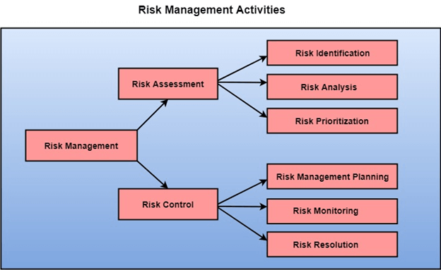

Software project risk control consists of three stages – risk management planning, risk monitoring, and risk resolution.

Project risk management planning can be of five types:

1. Crisis management: Address risks after they pose a threat to project delivery, survival, or continuity.
2. Risk mitigation: Plan ahead of risk occurrence and provide resources to recover from them beforehand.
3. Prevention: Implement plans as a part of a software project to identify and remove risk factors before they become a problem.
4. Elimination of root causes: Implement strategies to identify and remove factors before they even give rise to any software risk.

An important concept in risk management is risk reduction leverage. Risk reduction leverage helps to choose the most suitable risk reduction method.

It allows teams to find out the difference between risk exposure estimations before and after applying risk reduction activity. It divides the difference value by the reduction activity cost as follows:

Risk reduction leverage = (risk exposure estimate before reduction – risk exposure estimate after reduction) / risk reduction cost

It is better to plan for the elimination of potential risk factors from the beginning of the software development project. Risk assessment at the beginning of technical activity lowers development time, costs, and effort by mitigating the final consequences of the software risks.

# RISK PLANNING

The risk planning method considers each of the key risks that have been identified and develop ways to maintain these risks.

For each of the risks, you have to think of the behavior that you may take to minimize the disruption to the plan if the issue identified in the risk occurs.

You also should think about data that you might need to collect while monitoring the plan so that issues can be anticipated.

Again, there is no easy process that can be followed for contingency planning. It rely on the judgment and experience of the project manager.

# Risk Control

It is the process of managing risks to achieve desired outcomes. After all, the identified risks of a plan are determined; the project must be made to include the most harmful and the most likely risks. Different risks need different containment methods. In fact, most risks need ingenuity on the part of the project manager in tackling the risk.

**There are three main methods to plan for risk management:**

1. **Avoid the risk:** This may take several ways such as discussing with the client to change the requirements to decrease the scope of the work, giving incentives to the engineers to avoid the risk of human resources turnover, etc.
2. **Transfer the risk:** This method involves getting the risky element developed by a third party, buying insurance cover, etc.
3. **Risk reduction:** This means planning method to include the loss due to risk. For instance, if there is a risk that some key personnel might leave, new recruitment can be planned.

**Risk Leverage:** To choose between the various methods of handling risk, the project plan must consider the amount of controlling the risk and the corresponding reduction of risk. For this, the risk leverage of the various risks can be estimated.

Risk leverage is the variation in risk exposure divided by the amount of reducing the risk.

**Risk leverage = (risk exposure before reduction - risk exposure after reduction) / (cost of reduction)**

# PERT TECHNIQUE

A PERT chart is a network diagram that allows project managers to create project schedules. They’re used in the **Program Evaluation Review Technique** (PERT) to represent a project timeline, estimate the duration of tasks, identify task dependencies and find the critical path of a project.

PERT charts are used by project managers to create realistic schedules by coordinating tasks and estimating their duration by assigning three time estimates for each; optimistic, most likely and pessimistic. This makes PERT charts useful when planning projects where the duration of activities is uncertain.

Use PERT charts during the planning phase of a project. They can help you determine the project’s critical path and the ideal time to start or finish tasks, which allows you to know which tasks need to be prioritized when creating your project schedule.

As noted, PERT charts show the dependent tasks in your project. These are tasks that can’t start or finish until another task starts or finishes. Knowing which tasks are dependent helps you prevent delays by planning ahead to make sure these dependent tasks are scheduled in the order they need to be completed.

Also, when planning a project, having an accurate forecast of its duration is crucial for resource scheduling. The PERT chart is a tool that can help you estimate the amount of time you’ll need to complete the project. It’s also very helpful when you’re working on more complex or larger projects.

A PERT chart is made up of nodes and directional arrows. Nodes are numbered boxes or circles. They represent an event or milestone in the project. The arrows are the tasks or activities that must be done before moving on to the next event or milestone.

Therefore, a PERT chart works by visualizing the project’s tasks and dependencies. This provides an overview of the project timeline, including which tasks are essential to complete to deliver a successful project. With this information, project managers can develop a viable project plan that meets deadlines and stays within budget.

**Terminology**

Here is a list of terms associated with PERT charts:

* **Nodes** are visual representations of milestones or events within the project. They are drawn as either numbered boxes or numbered circles.
* **Arrows** are visual representations of the tasks that occur throughout the project. The direction of the arrow indicates the sequence of the task. Diverging arrows show that various tasks can be completed at the same time.
* **Fast tracking** is when tasks and activities are performed simultaneously.
* A **PERT event** is the point at which one or more tasks are started or completed.
* A **predecessor event** occurs immediately *before*some events. A **successor event** naturally occurs *after* events.
* **Slack** is the amount of time a single task can be delayed without harming other tasks or the project as a whole.
* The **critical path** is the longest -- or most time-consuming -- path from the start to the completion of an event or task.
* **Critical path activity** refers to a task that does not experience slack.
* **Crashing critical path** is when the completion time of a task is shortened.
* **Lag time** refers to the earliest point at which a task can follow another.
* **Lead time** is the amount of time it should take to complete a task without impacting the following activities.
* **Expected time** is the best estimation of how long a task will take to complete, taking into consideration any problems or obstacles that might arise.
* **Optimistic time** refers to the minimum amount of time it will take to complete a task.
* **Pessimistic time** is the maximum amount of time it will take to finish a task.
* **Most likely time** is the best guess of how long a task will take, assuming no problems arise.

Differences between the PERT and the CPM

|  |  |
| --- | --- |
| CPM | PERT |
| Activity durations are well defined | Time estimations are uncertain |
| It is a method of control of time and costs | It is a technique of planning and control of time |
| Only one estimate | There are 3 estimates (optimistic, pessimistic, and most likely |
| 4 relationship types (FS, SS, SF, FF) | Only FS relationship type |

**Creating the PERT chart**

Creating a PERT chart shouldn’t be an overwhelming process, even if you decide to draw your PERT diagram and do the calculations yourself. Here are some simple steps to create a PERT chart:

**1. Break Down Your Project Scope**

Begin by identifying the project milestones and then identify the individual tasks required to achieve them. Then, figure out the sequence of your project tasks and their dependencies.

You should have a list of milestones, tasks and their dependencies. You’ll need these elements to create your PERT chart, either manually or using project management software.

**2. Create Your PERT Chart**

During this phase, you’ll need to sequence your tasks using the PERT diagram and estimate the time required to complete each task.

**3. Estimate Your Project Duration**

Now that you have drafted a PERT diagram and added task details, it’s time to add the estimated durations of all tasks to create a project schedule. If you’re drawing your PERT diagram, you’ll use the PERT chart formula to do so.

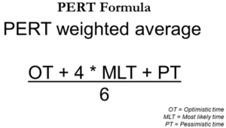

The PERT method employs simple statistic calculations. It uses three-time estimations.

* Optimistic Estimate: The shortest time required to complete the task.
* Pessimistic Estimate: The longest time required to complete the task.
* Most Likely Estimate: The most possible time (probable duration) required to complete the task.

Expected time is calculated with the help of the PERT Analysis formula below

Expected time = (Optimistic + 4 x Most likely + Pessimistic) / 6

**4. Find the Critical Path & Slack**

While CPM and PERT are two different methods, once you have a PERT chart that has your project tasks, their durations and due dates, you can calculate the critical path and identify any possible slack. At last, you have your PERT chart! Remember, this project management chart is a living document that must be returned to and revised as the project progresses.

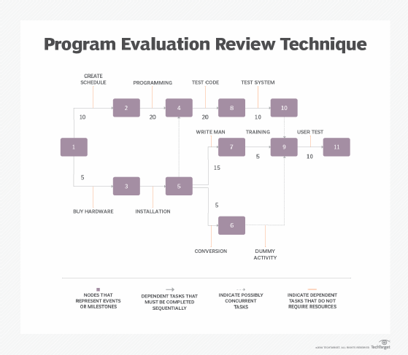

In the following example, you are a project manager of a power plant project. You tracked the steps mentioned above and listed the following inputs;

* All the Activities
* Predecessors
* Optimistic, Pessimistic, and Most Likely Activity Durations  
  By using “The Pert Formula = (To + 4Tm + Tp)/6”, you calculated the expected duration for each activity.  
  All the inputs are listed in the table below.

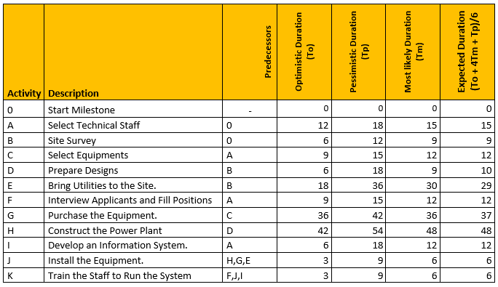

After building a network diagram and estimating the activity durations, you will determine the critical path by making forward and backward pass calculations.  
Forward Pass Calculations specify the minimum dates at which each activity can be performed and, ultimately, the minimum duration of a project.

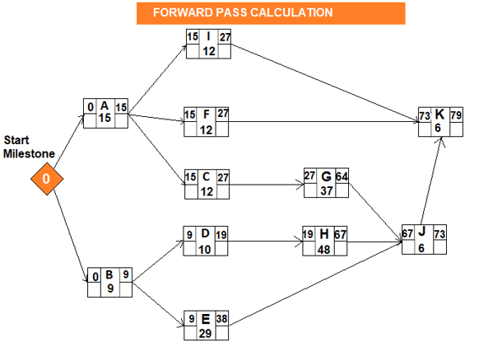

Backward Pass Calculations of Program Evaluation and Review Technique determine the latest dates by which each activity can be performed without increasing the project’s minimum duration.

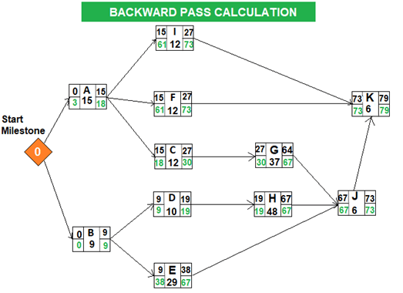

After completing the backward pass calculation, you can easily determine the critical path. In project management, “float” or “slack” is the amount of time that a task can be delayed without affecting the deadlines of other subsequent tasks, or the project’s final delivery date. Total float/slack is 0 on the critical path.

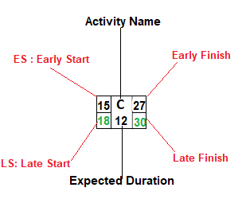

Total Float: LS – ES = 18-15 = 3  
Total Float: LF – EF = 30-27 = 3

The total float can be calculated by subtracting the Early Start date of an activity from its Late Start date or Early Finish date from its Late Finish date.

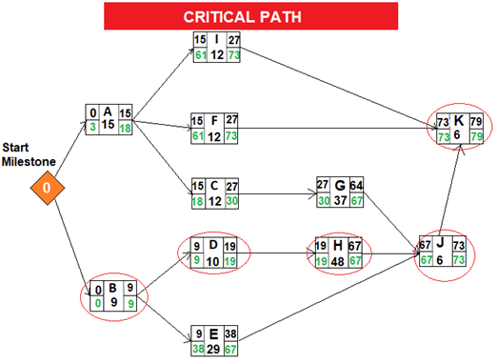

When we analyze the network diagram we will see that there are some paths and every path have duration.  
The critical path is the longest path in the network diagram and the total float of the critical path is zero.

**Network Diagram**

The network diagram is important for the project schedule because it leads to determining the critical path. There are 2 ways to draw the network diagram.

* Activity on Arrow (AoA) - in which the activities are represented by arrows. These arrows are then connected by nodes, with the back of the arrow indicating the start of the activity and the front point the end. This type of diagram only shows finish-to-start dependencies between activities.
* Activity on Node (AoN) - In this type of diagram, the activities are represented by nodes. The nodes are then connected to one another by arrows. These arrows are used to show the relationship between the activities. Unlike the above diagramming, all four types of dependencies can be shown—finish to start, start to start, finish to finish and start to finish.

Example:

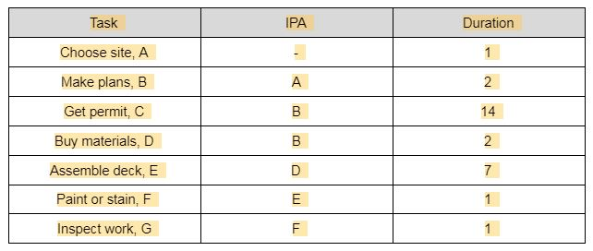

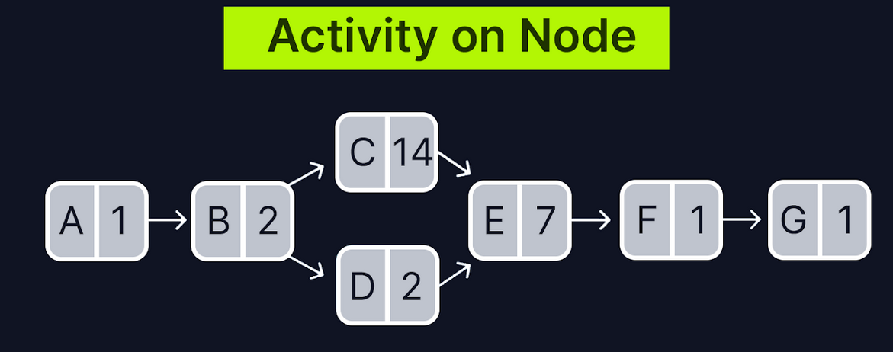

Credit: https://www.projectmanager.com

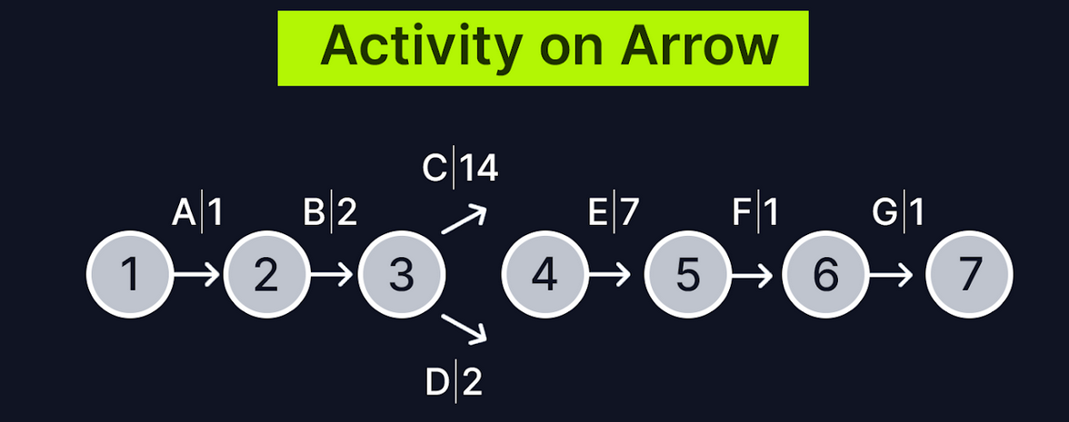

Below are the AON graphical representations for certain relationships that occur in project activities:

*1. A comes before B, which comes before C.*



*2. A and B must both be completed before C can start.*

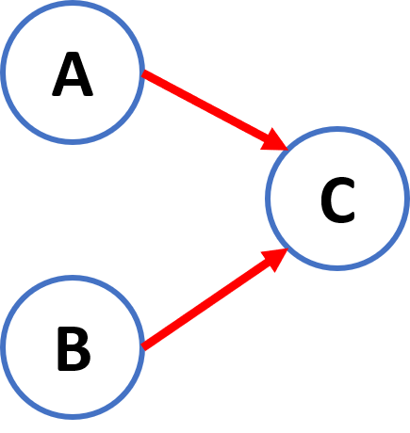

*3. B and C cannot begin until A is completed.*

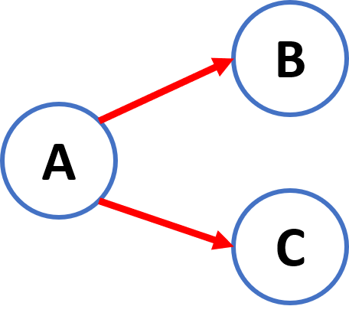

*4. C and D cannot begin until both A and B are completed.*

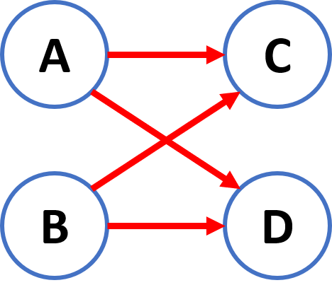

*5. C cannot begin until both A and B are completed; D cannot begin until B is completed.*

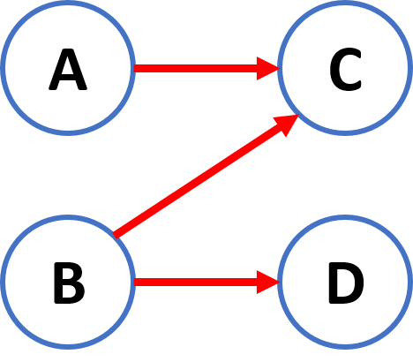

*6. B and C cannot begin until A is completed. D cannot begin until both B and C are completed.*

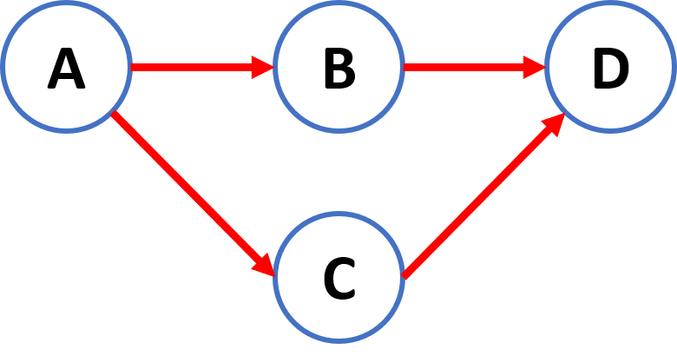

**Differences**

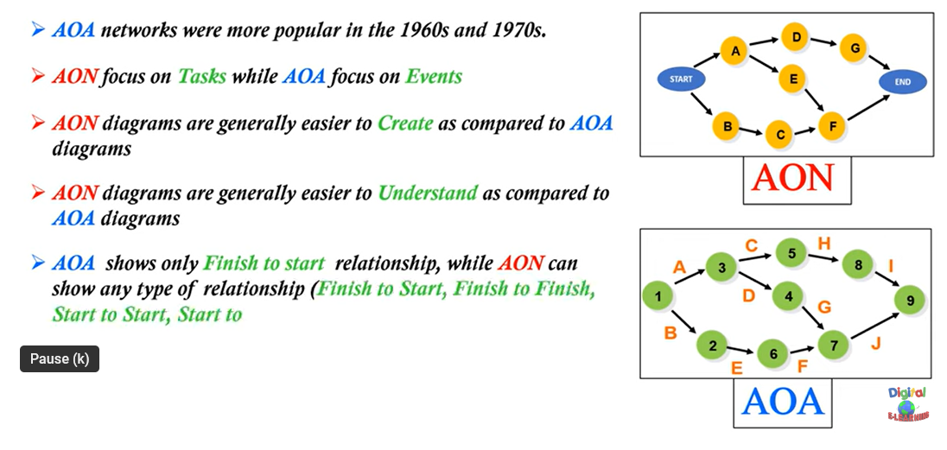

# CREATION OF CRITICAL PATHS

The **critical path method (CPM)** is a sophisticated project management technique for planning, scheduling, and managing the tasks necessary to complete a project from start to finish. It is also sometimes referred to as **critical path analysis (CPA)**.

The critical path method does two main things:

1. It helps project managers find the most important tasks in a project that *critically* affect how long a project will take.
2. It helps project managers make an efficient schedule so they can finish the entire project on time and within budget.

The Critical Path Method is essentially an algorithm for decision-making. This algorithm takes a task's start, duration, and finish time to determine which activities deserve the most attention (i.e., are "critical" for the project).

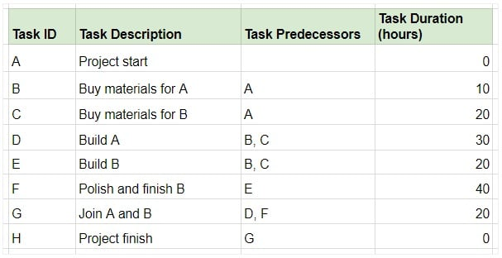

To do this, organize all tasks into a flowchart and note their durations next to the task ID. The arrows indicate the sequence of activities. We'll mark the Earliest Start (ES) time to the left of the activity and the Earliest Finish (EF) time to the right.:

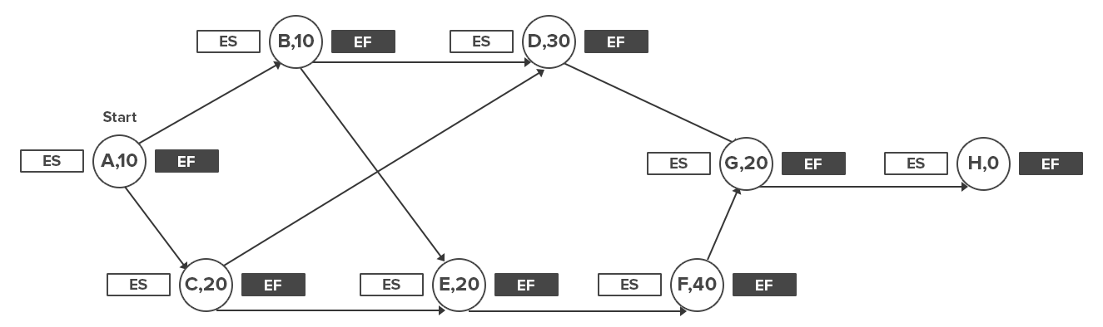

Mark the Start Time (S) to the left and right of the first activity. Usually, this would be 0.

Now mark the Earliest Start (ES) time of each activity. This is given by the largest number to the right of the activity's immediate predecessor (i.e. its Earliest Finish time, or EF).

If the activity has two predecessors, the one with the later EF time would give you the ES of the activity.

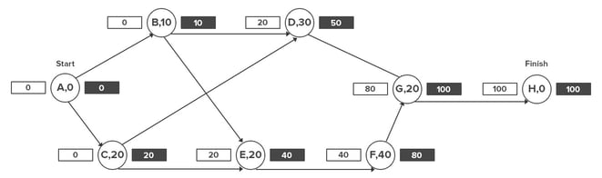

The EF of an activity is given by its Earliest Start time (ES) and its duration (t), i.e. ES + t.

Thus, if an activity's ES is 20 and lasts 10 days, its EF will be 30.

Mark all these figures in the flowchart.

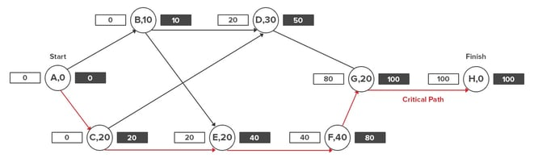

The longest path will be the “critical path”.

The final figure to the right of the last task in the sequence shows the minimum time the project will take to finish.

**Float or Slack in Project Management**

In project management, “float” defines the amount of time a task can be delayed without causing a delay in:

1. Any subsequent, dependent tasks are called “free float.”
2. Any delay in the overall project is called “total float.”

Any activity or task on the critical path has zero float. That is, you can’t delay it without causing a delay in the project or dependent tasks.

However, plenty of other activities in the project can be delayed. The quantification of this delay is called the “float.”

# MONTE CARLO SIMULATION

Monte Carlo Simulation is a type of computational algorithm that uses repeated random sampling to obtain the likelihood of a range of results of occurring.

Also known as the Monte Carlo Method or a multiple probability simulation, Monte Carlo Simulation is a mathematical technique that is used to estimate the possible outcomes of an uncertain event. The Monte Carlo Method was invented by John von Neumann and Stanislaw Ulam during World War II to improve decision making under uncertain conditions.

Monte Carlo Simulation predicts a set of outcomes based on an estimated range of values versus a set of fixed input values. In other words, a Monte Carlo Simulation builds a model of possible results by leveraging a probability distribution, such as a uniform or normal distribution, for any variable that has inherent uncertainty. It, then, recalculates the results over and over, each time using a different set of random numbers between the minimum and maximum values. In a typical Monte Carlo experiment, this exercise can be repeated thousands of times to produce a large number of likely outcomes.

For example, let’s say you don’t know how long your project will take. You have a rough estimate of the duration of each project task. Using this, you develop a best-case scenario (optimistic) and worst-case scenario (pessimistic) duration for each task.

You can then use Monte Carlo to analyze all the potential combinations and give you probabilities of when the project will complete.

The results would look something like this:

* 2% chance of completing the project in 12 months (if every task finished by the optimistic timeline)
* 15% chance of completion within 13 months
* 55% chance of completion within 14 months
* 95% chance of completion within 15 months
* 100% chance of completion within 16 months (If everything takes as long as the pessimistic estimates)

Using this information, you can now better estimate your timeline and plan your project.

**How to use Monte Carlo methods**

Regardless of what tool you use, Monte Carlo techniques involves three basic steps:

1. Set up the predictive model, identifying both the dependent variable to be predicted and the independent variables (also known as the input, risk or predictor variables) that will drive the prediction.
2. Specify probability distributions of the independent variables. Use historical data and/or the analyst’s subjective judgment to define a range of likely values and assign probability weights for each.
3. Run simulations repeatedly, generating random values of the independent variables. Do this until enough results are gathered to make up a representative sample of the near infinite number of possible combinations.

You can run as many Monte Carlo Simulations as you wish by modifying the underlying parameters you use to simulate the data. However, you’ll also want to compute the range of variation within a sample by calculating the variance and standard deviation, which are commonly used measures of spread. Variance of given variable is the expected value of the squared difference between the variable and its expected value. Standard deviation is the square root of variance. Typically, smaller variances are considered better.

# RESOURCE ALLOCATION

Resource allocation is the process of scheduling resources such as labor, materials or equipment for the completion of project tasks. Resource allocation is a step of project resource management that involves estimating resources, procuring resources, allocating resources and tracking resources until the project is completed.

In project management, resources are often in high demand but low in availability. This reality puts project managers in a position where they must strategize the best ways to use what they have. They need to determine who does what, when, and with what tools or support. It’s a balancing act that requires keen insight into the project's needs and the capabilities of the resources at hand. This keeps costs down, maximizes productivity and helps with team morale. It also facilitates client satisfaction by achieving the best outcome and successfully delivering the project.

Resource allocation is a plan that you develop with the aim of making the most of the available resources at your disposal in a project, which makes it a critical resource planning activity.

The following are some general tips to help you with your resource allocation when managing a project.

**1. Define Your Project Scope**

Before you can allocate your resources or manage them, you have to determine the scope of the project you’re working on. To do so, you need to break down the project into every individual task and deliverable that will be completed. Once you’ve done so, you can make the right decision on what resources you’ll need and how many of them are necessary to complete the project.

The clearer the project scope is, the better you’ll be able to figure out how to allocate your resources. Take the time to get the full picture of the project using a work breakdown structure or other project planning tools to visualize all your project tasks before estimating your resources.

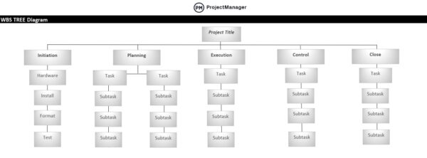

**2. Estimate What Project Resources Will Be Needed**

Once you have defined your project scope, you can move to the resource planning phase which is when you’ll have to estimate what resources will be needed including people, equipment, materials and anything else you’re going to need to complete your project tasks. Your organization will have some of these resources already, while others will need to be purchased or rented.

Before you can allocate resources, you have to have them. So, make a list using the criteria above and then make sure it fits within the project budget.

**3. Assess Your Current Resource Utilization & Resource Availability**

Now that you’ve determined what resources are required for your project, you should also identify which of those resources are available within your organization. However, some existing resources might be being used for other projects, so it’s important that you not only identify which resources your organization has but also which of those are being utilized.

**4. Create a Resource Allocation Plan**

Take the information that you’ve gained from the above steps to put together a resource allocation plan. Outline the list of resources you’ll need for your project as well as the cost and quantity of each. When you’re finished, circle back to your project scope to make sure your plan aligns with it.

**5. Keep Track of Your Project Resources**

It’s a problem when you’re so focused on the process that you neglect to lift your head from the resource allocation plan to note what’s actually happening. This isn’t merely tracking your estimates against actual progress in the project, though that’s important, too.

**6. Use Resource Allocation Reports**

You can reallocate if you don’t know where your resources are allocated. You might have planned them out well, but change happens in projects. How can you tell what’s happening on the ground compared to your plans? Project reports.

You can generate all sorts of reports to give you a full picture of the project and how it’s progressing, which helps you balance your resources. For example, resource reports give you an overview of your team’s workload and whether they’re over-tasked or idle.

**Resource Allocation Methods**

The specific resource allocation method that your organization implements depends on your industry and the nature of how resources are managed. For example, manufacturing companies might focus on raw materials and equipment while a professional services company might focus on team utilization and financial resources.

Some commonly utilized resource allocation methods for you to consider.

* **Critical Path Method:** In project management, the longest chain of dependent tasks is referred to as the critical path. By outlining a straightforward priority for task completion before the project starts, the CPM helps use resources as efficiently as possible. However, one criticism is that this method doesn’t allow for multitasking.
* **Resource Leveling:** To implement resource leveling, start by looking at the capacity of your team to determine how much work they can handle. Compare this with demand. If resources aren’t aligned with demand, reschedule tasks accordingly.
* **Resource Smoothing:** Resource smoothing aims to reduce demand while executing the project within the ideal timeframe. During this method, the project manager makes adjustments to resource scheduling and allocation. For example, if you’re under a time crunch, you might bring on a more seasoned person who can complete the work faster.

# COST SCHEDULES